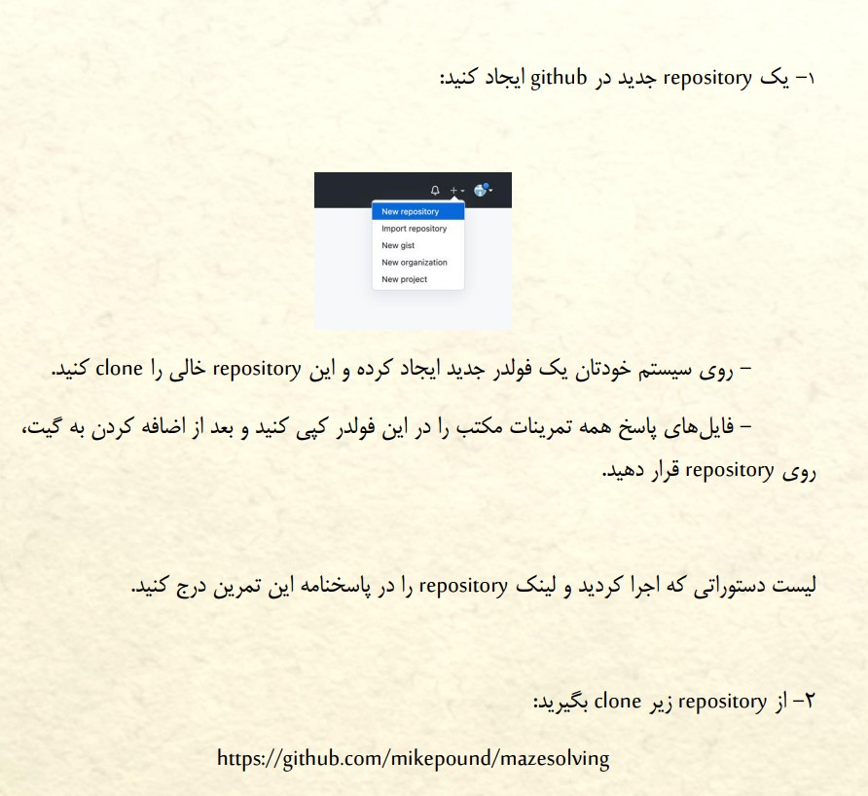



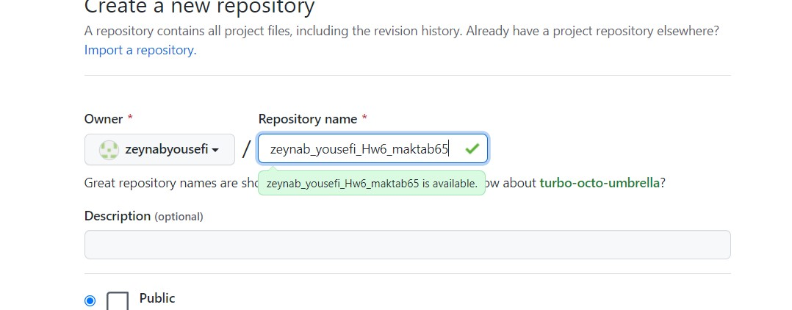

<https://github.com/zeynabyousefi/zeynab_yousefi_Hw6_maktab65>

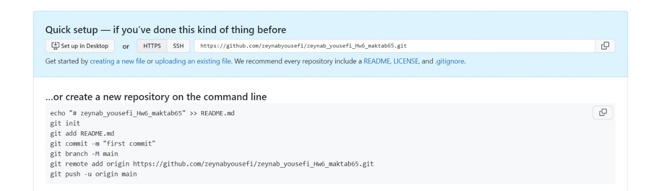

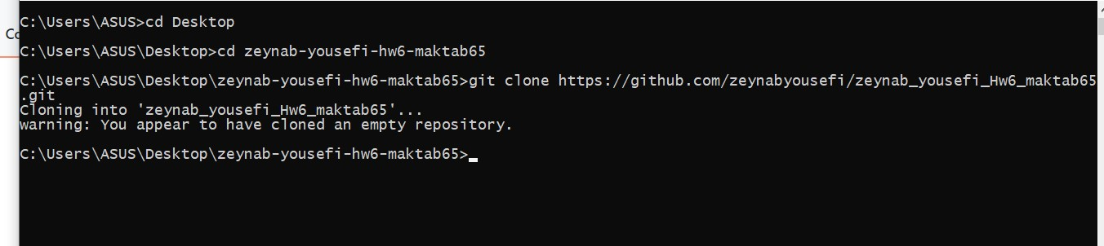

Clone an empty repository <https://github.com/zeynabyousefi/zeynab_yousefi_Hw6_maktab65>

Clone a repository [GitHub - mikepound/mazesolving: A variety of algorithms to solve mazes from an input image](https://github.com/mikepound/mazesolving)

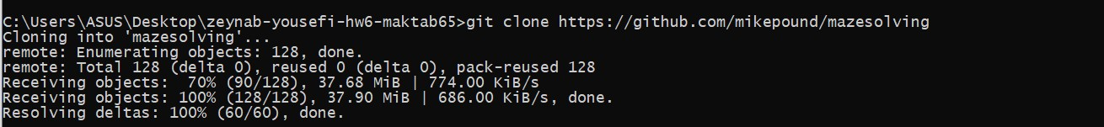

* + git log

List commit history of current branch. -n count limits list to last n commits.

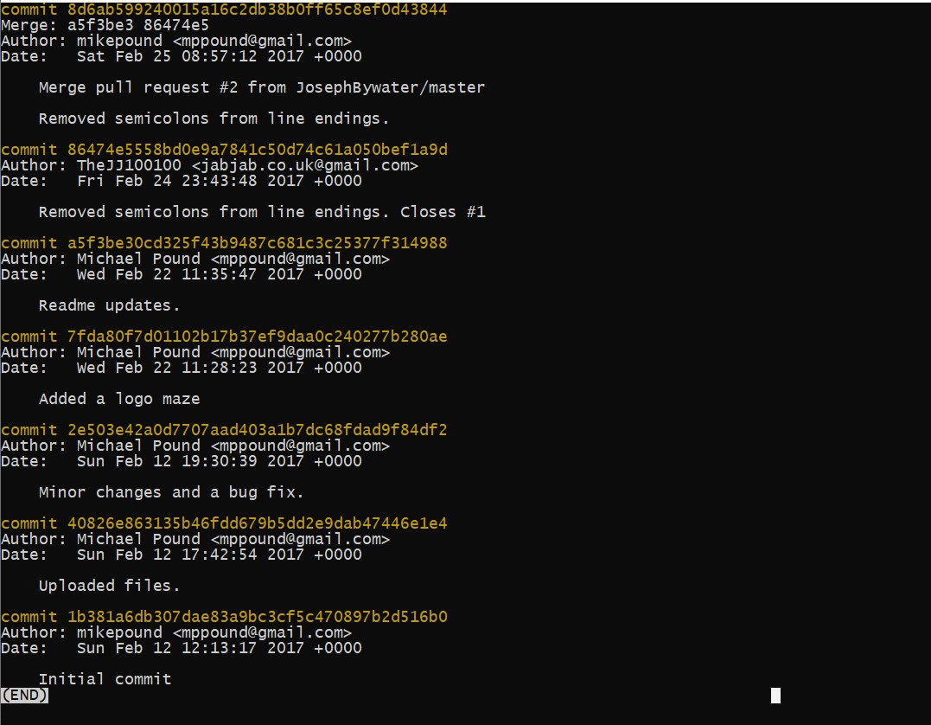

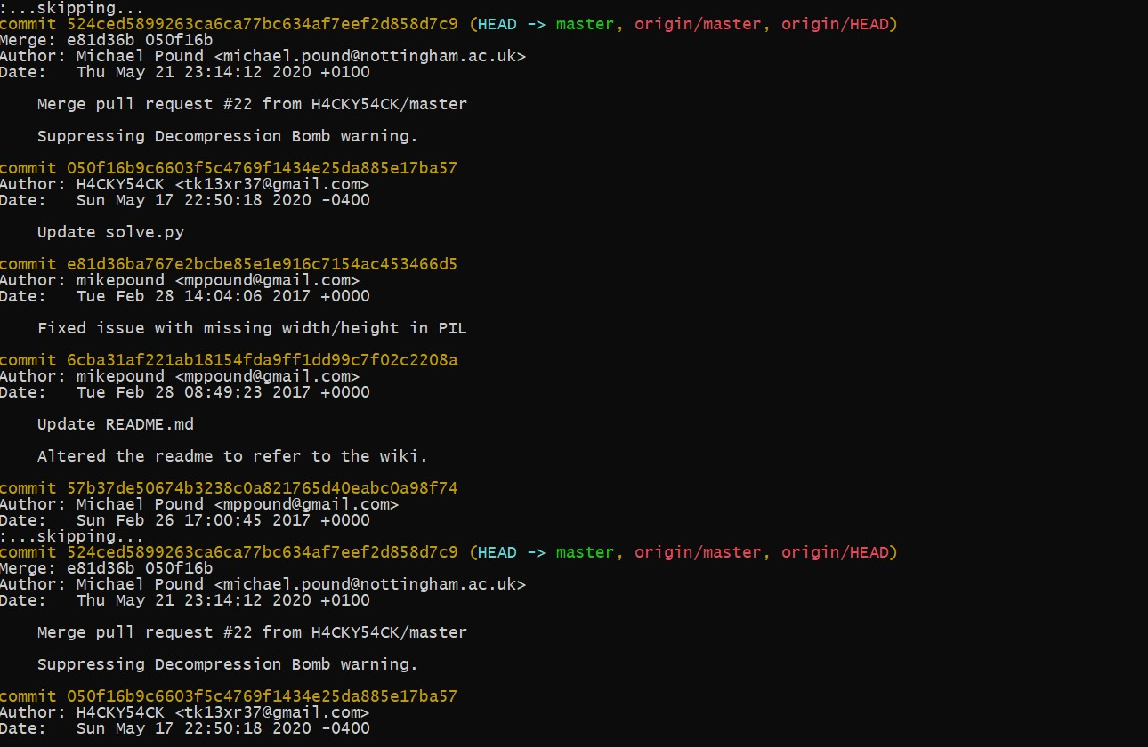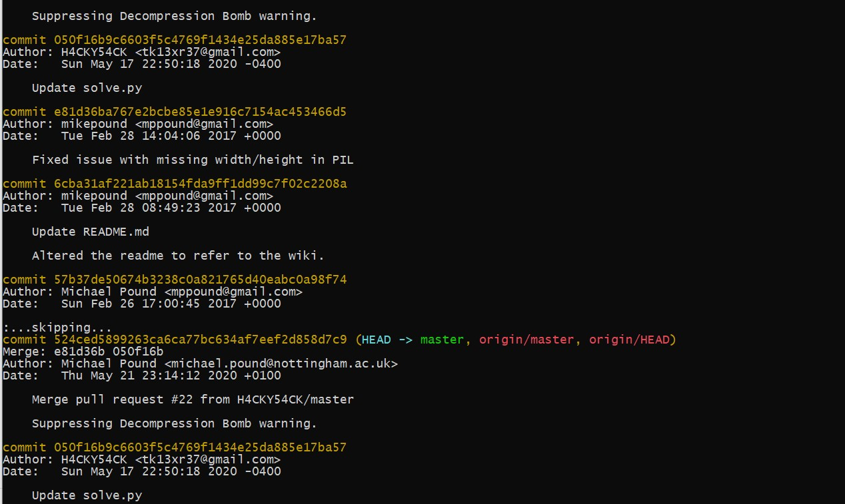

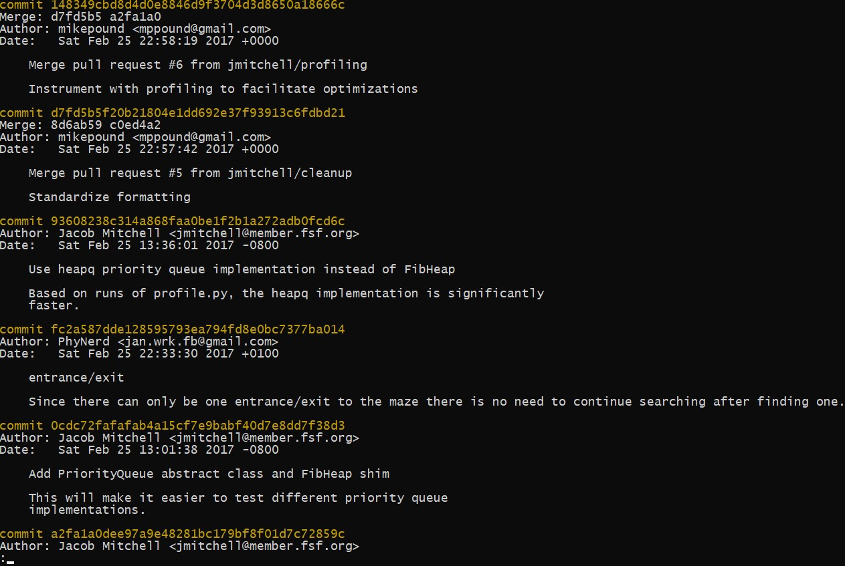

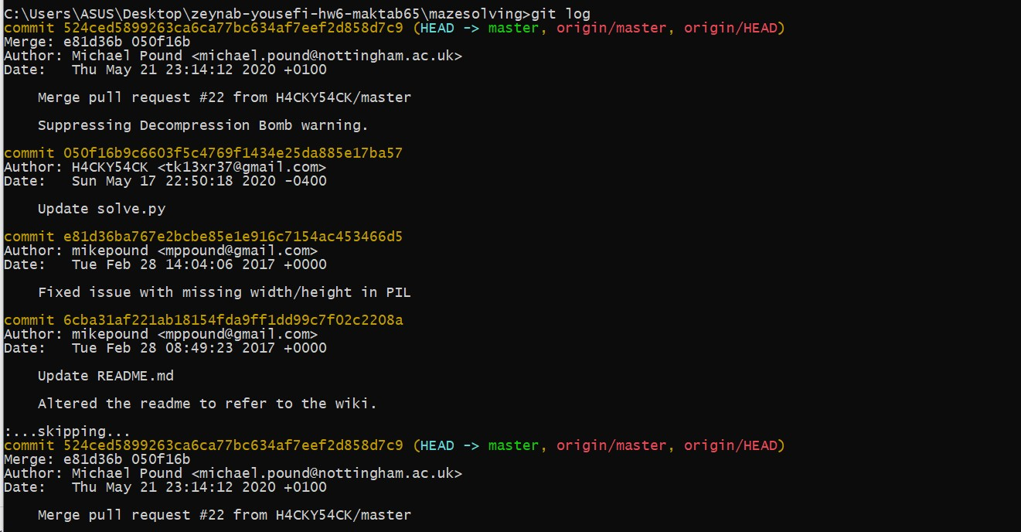

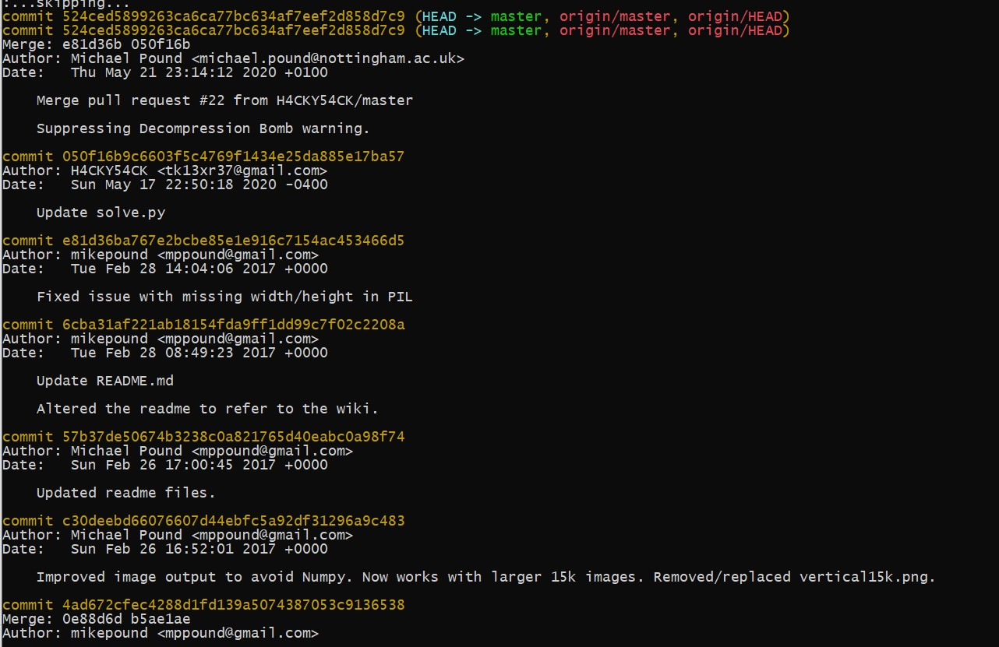

View differences of two commits:

git diff <commit_1> <commit_2>

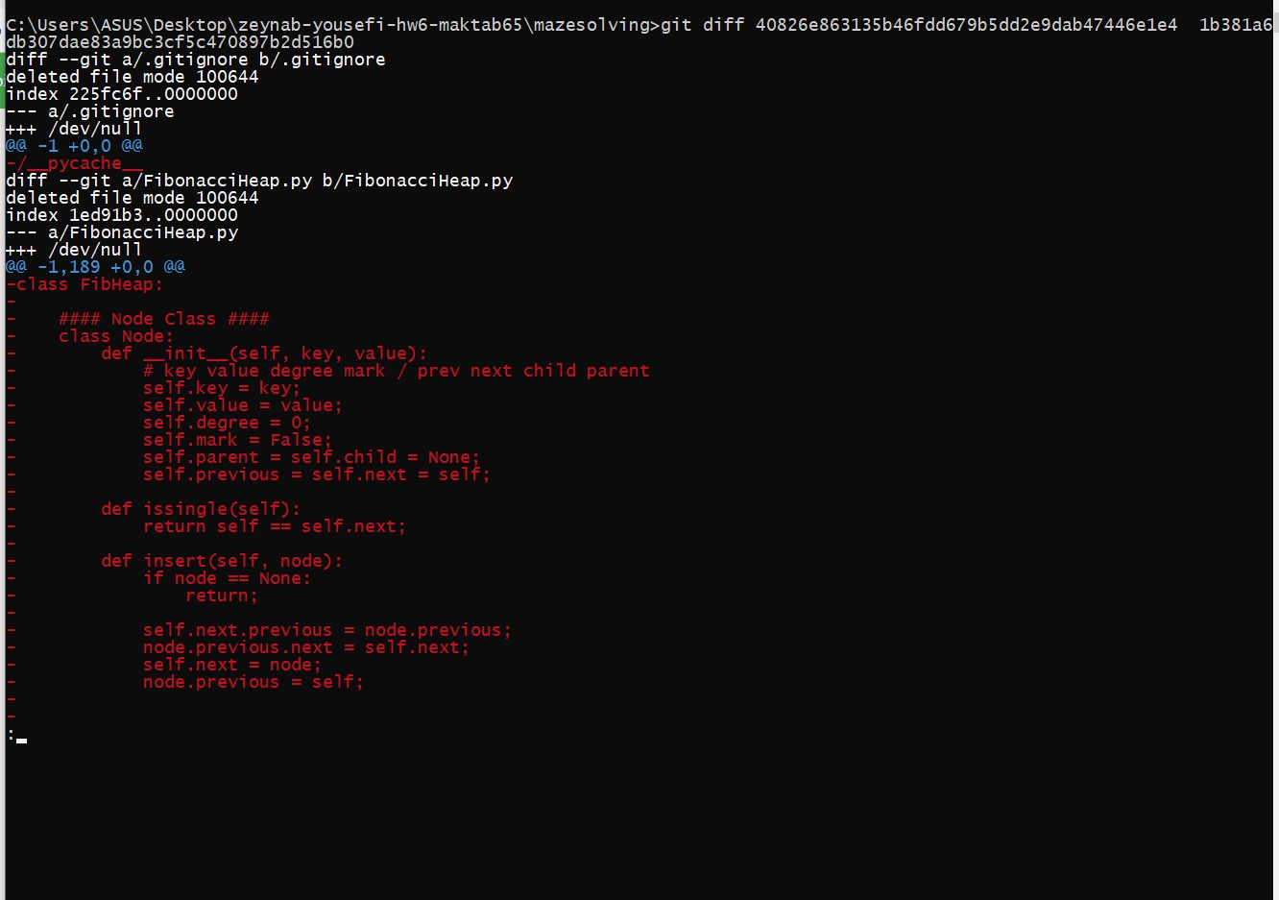

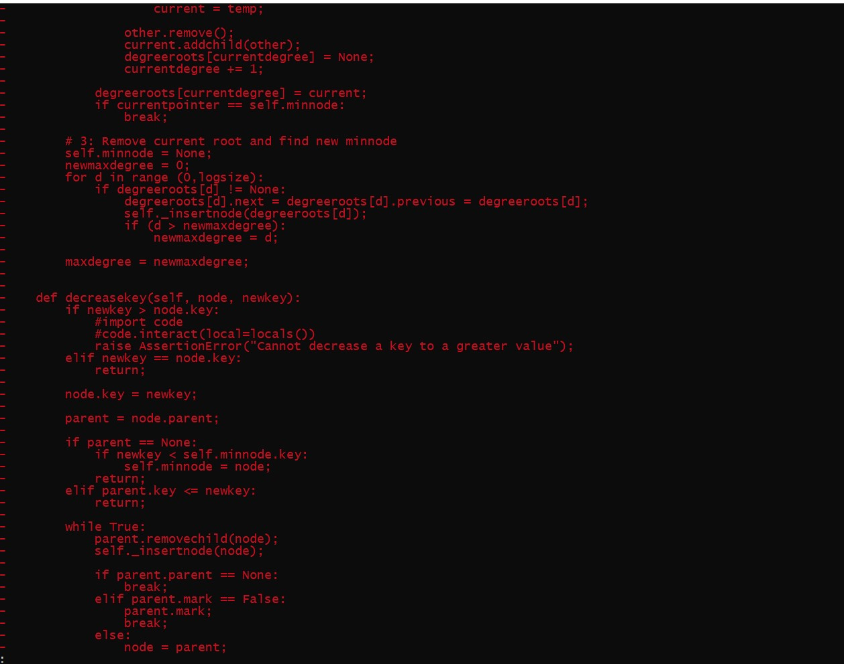

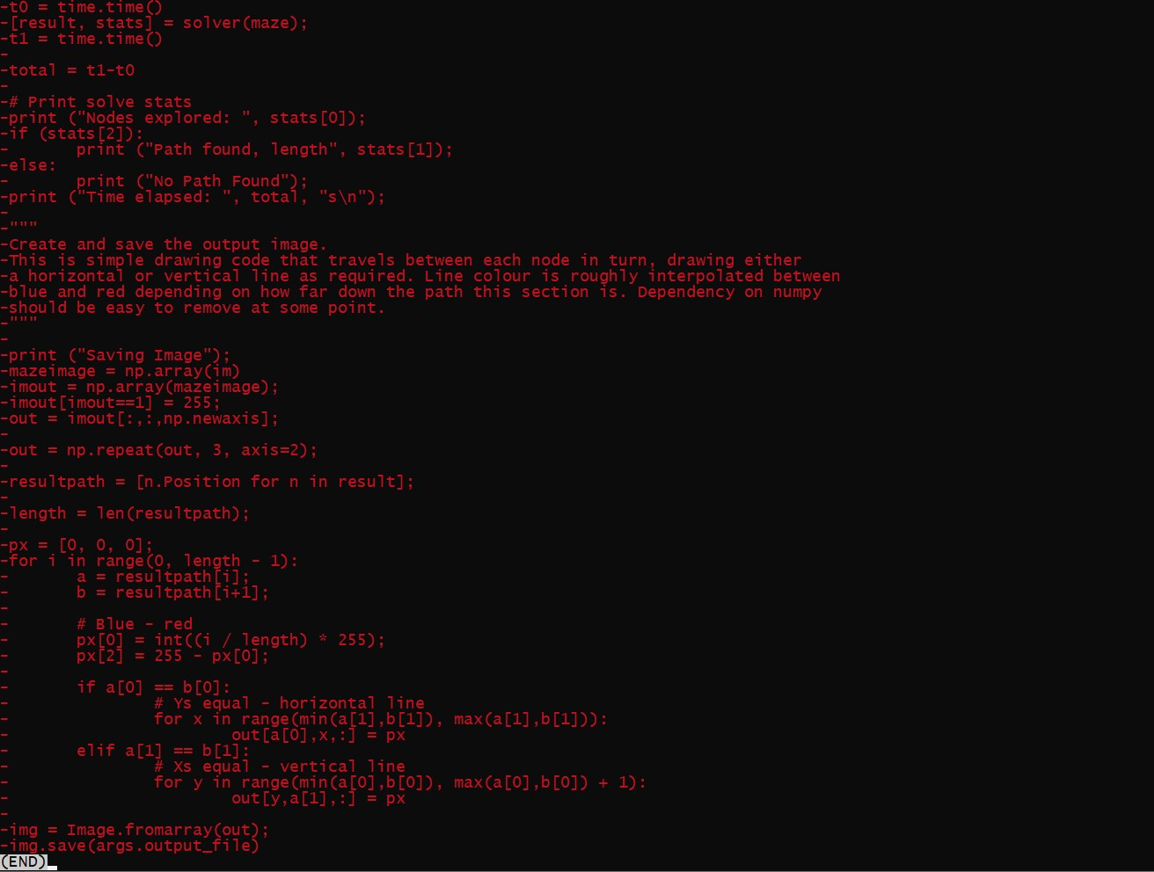

$ git checkout -b branch_name Switch working directory to the specified branch. With -b: Git will create the specified branch if it does not exist

Add a python file in file and add in git(in new branch)

Git branch (show list of branch)

$ git add file name

And commit it

And git log (history commit)



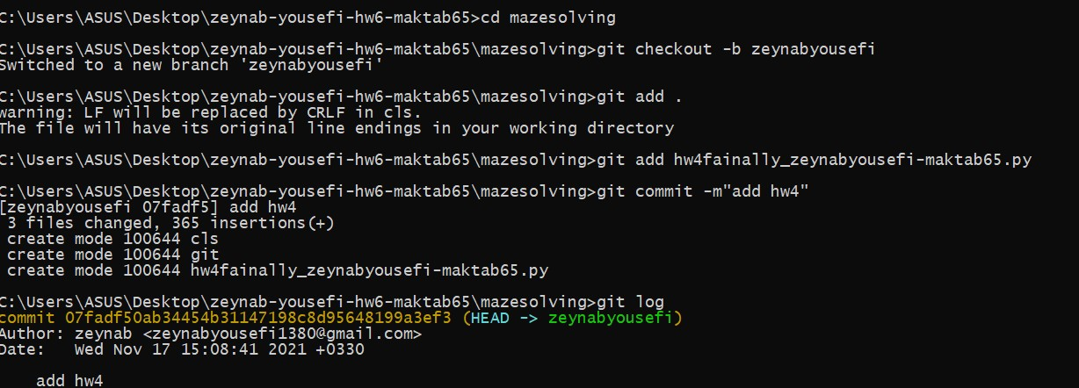

Git push in repository

https://github.com/zeynabyousefi/zeynab_yousefi_Hw6_maktab65

